УО «Белорусский государственный университет информатики и радиоэлектроники»

Кафедра ПОИТ

Отчёт по лабораторной работе №6

По предмету

Базы данных

Выполнил:

Гладкий М.Г.

Проверил:

Фадеева Е.Е.

Группа 851005

Минск 2021

Предметная область: Интернет-магазин компьютерных игр

Даталогическая модель:

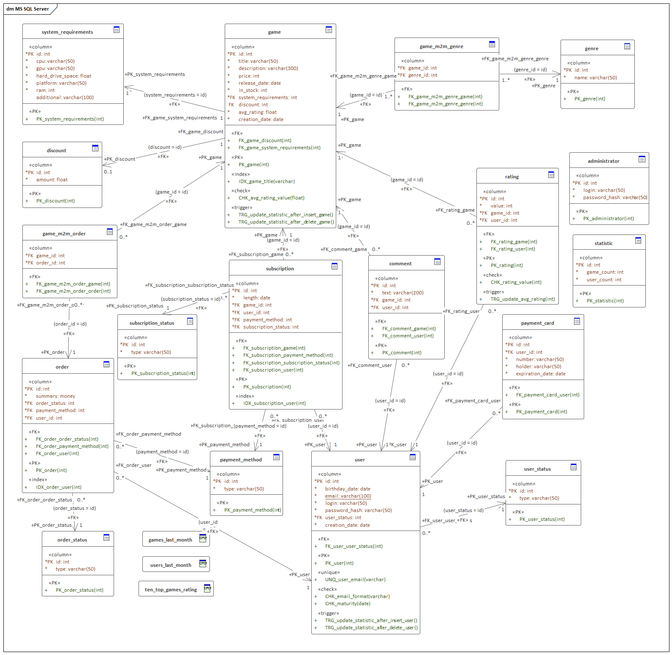

1) Каскадные операции:

Были настроены следующие каскадные операции:

FK_game_discount: ON DELETE – No action, ON UPDATE – Cascade;

FK_game_system_requirements: ON DELETE – No action, ON UPDATE – Cascade;

FK_game_m2m_genre_game: ON DELETE – Cascade, ON UPDATE – Cascade;

FK_ game_m2m_genre_genre: ON DELETE – Cascade, ON UPDATE – Cascade;

FK_game_m2m_order_game: ON DELETE – Cascade, ON UPDATE – Cascade;

FK_ game_m2m_order_order: ON DELETE – Cascade, ON UPDATE – Cascade;

FK_order_order_status: ON DELETE – No action, ON UPDATE – Cascade;

FK_order_payment_method: ON DELETE – No action, ON UPDATE – Cascade;

FK_order_user: ON DELETE – No action, ON UPDATE – Cascade; Заказы должны оставаться в базе данных для правильного подсчета средств.

FK_subscription_game: ON DELETE – No action, ON UPDATE – Cascade; Подписки остаются в БД всегда.

FK_subscription_payment_method: ON DELETE – No action, ON UPDATE – Cascade;

FK_subscription_subscription_status: ON DELETE – No action, ON UPDATE – Cascade;

FK_subscription_user: ON DELETE – No action, ON UPDATE – Cascade;

FK_comment_game: ON DELETE – Cascade, ON UPDATE – Cascade;

FK_comment_user: ON DELETE – Cascade, ON UPDATE – Cascade;

FK_rating_game: ON DELETE – Cascade, ON UPDATE – Cascade;

FK_rating_user: ON DELETE – Cascade, ON UPDATE – Cascade;

FK_user_user_status: ON DELETE – No action, ON UPDATE – Cascade;

FK_payment_card_user: ON DELETE – Cascade, ON UPDATE – Cascade;

2) Представления:

Выборка 10 игр с высочайшим рейтингом

CREATE VIEW 'ten_top_games_rating' AS

SELECT **\*** FROM 'game'

ORDER BY 'avg_rating' DESC

LIMIT 10

Выборка игр, добавленных за последний месяц

CREATE VIEW 'games_last_month' AS

SELECT **\*** FROM 'game' WHERE DATE**(**'creation_date'**)** **>** **(**CURDATE**()** **-** INTERVAL 1 MONTH**)**

Выборка пользователей, зарегистрированных за последний месяц

CREATE VIEW 'users_last_month' AS

SELECT **\*** FROM 'user' WHERE DATE**(**'creation_date'**)** **>** **(**CURDATE**()** **-** INTERVAL 1 MONTH**)**

3) Проверки:

Валидность email пользователя

ALTER TABLE 'user'

ADD CONSTRAINT 'CHK_email_format'

CHECK **(**'email' REGEXP '^[^@][+@[^@]+\.[^@]+$](mailto:+@[%5e@]+\.%5b%5e@%5d+$)'**)**

Проверка рейтинга на значения от 1 до 10

ALTER TABLE 'rating'

ADD CONSTRAINT 'CHK_rating_value'

CHECK **(**'value' BETWEEN 1 AND 10**)**

ALTER TABLE 'game'

ADD CONSTRAINT 'CHK_avg_rating_value'

CHECK **(**'avg_rating' BETWEEN 1 AND 10**)**

Пользователь совершеннолетний

ALTER TABLE 'user'

ADD CONSTRAINT 'CHK_maturity'

CHECK DATEDIFF**(**CURDATE**(),** DATE**(**'birthday_date'**))** **/** 365 **>=** 18

4) Триггеры:

Обновление среднего рейтинга игры после вставки, обновления или удаления рейтинга, поставленного пользователем

CREATE TRIGGER `TRG_update_avg_rating` AFTER INSERT**,** UPDATE**,** DELETE ON `**rating**`

FOR EACH ROW BEGIN

UPDATE `**game**` SET

`avg_rating` **=** SELECT AVG**(**`value`**)** FROM `**rating**` WHERE `game_id` **=** OLD**.**`game_id`**,**

WHERE `id` **==** OLD**.**`game_id`**;**

END**;**

Обновление статистики после вставки/удаления пользователя

CREATE TRIGGER `TRG_update_statistic_after_insert_user` AFTER INSERT ON `user`

FOR EACH ROW BEGIN

UPDATE `**statistic**` SET `user_count` **=** `user_count` **+** 1

END**;**

CREATE TRIGGER `TRG_update_statistic_after_delete_user` AFTER DELETE ON `user`

FOR EACH ROW BEGIN

UPDATE `**statistic**` SET `user_count` **=** `user_count` **-** 1

END**;**

Обновление статистики после вставки/удаления игры

CREATE TRIGGER `TRG_update_statistic_after_insert_game` AFTER INSERT ON `**game**`

FOR EACH ROW BEGIN

UPDATE `**statistic**` SET `game_count` **=** `game_count` **+** 1

END**;**

CREATE TRIGGER `TRG_update_statistic_after_delete_game` AFTER DELETE ON `**game**`

FOR EACH ROW BEGIN

UPDATE `**statistic**` SET `game_count` **=** `game_count` **-** 1

END**;**